AI writing tutor QA

Review section (step 3):
Tabs should be introduction, body paragraph 1, body paragraph 2 and conclusion

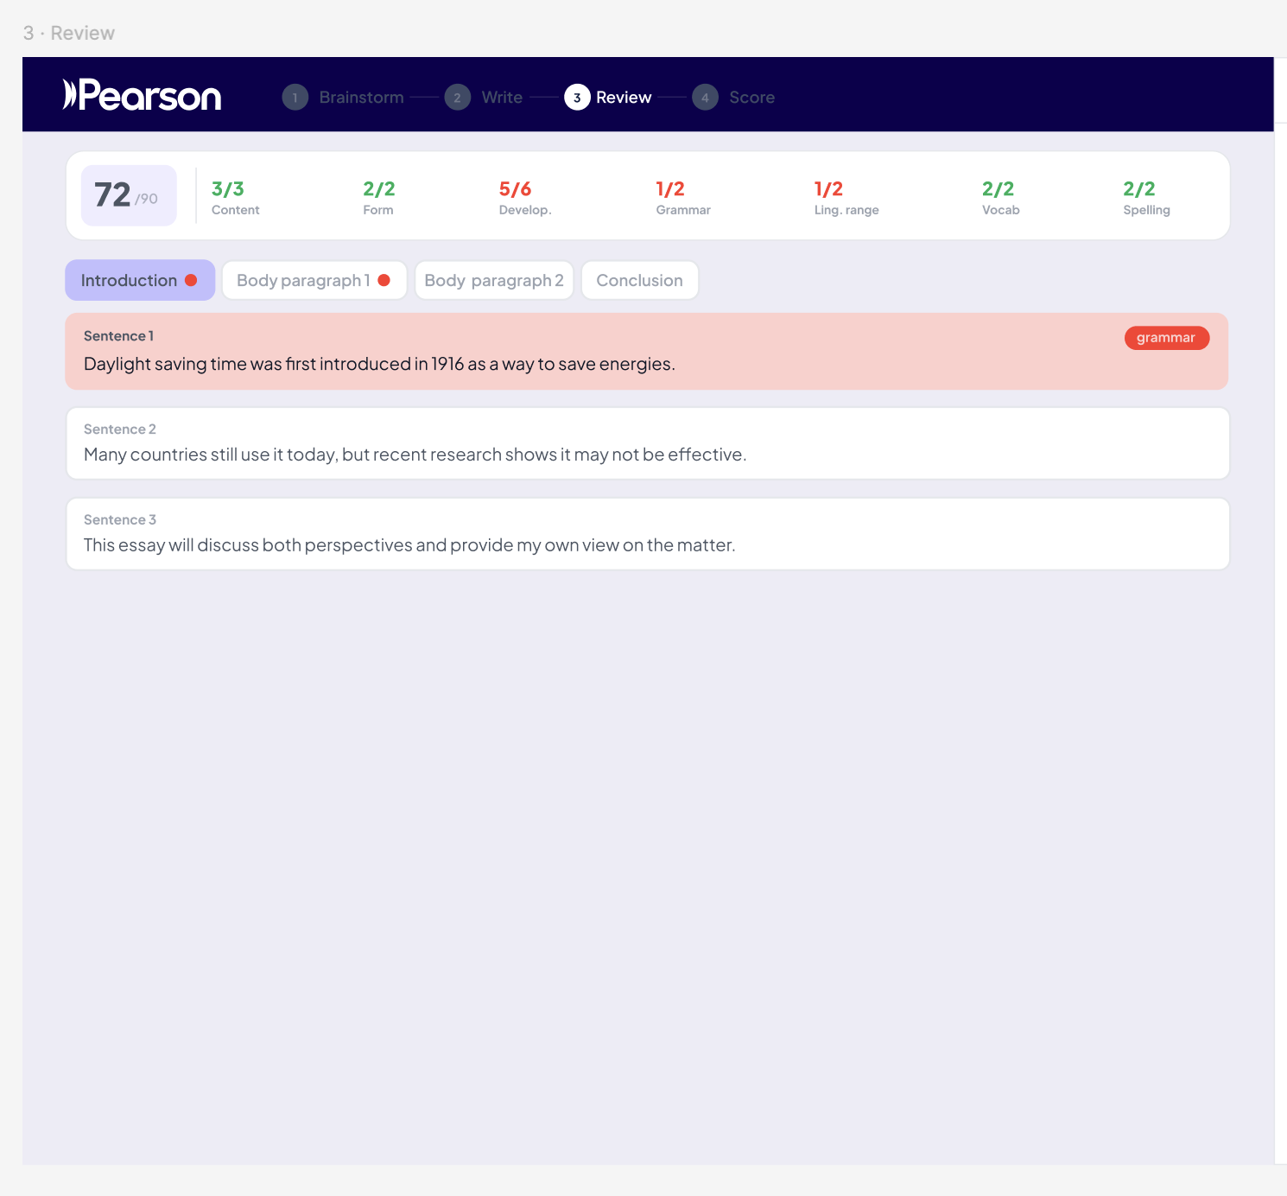
Review (step 3) currently showing different result than score (step 4) screen. 13/90 and 63/90.

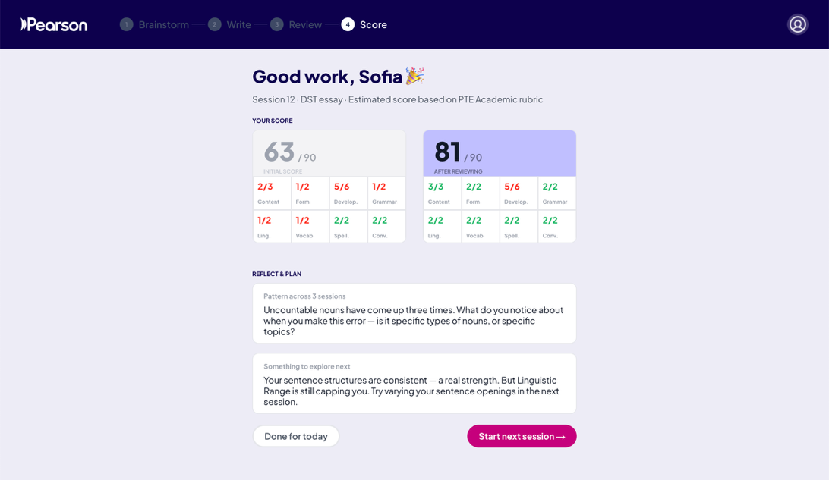
Quiz should display full sentence instead of just a single word
